FAST Man EFI
21575 Apple Hill Dr
Sonora, CA 95370
209-247-6497

Holley EFI
Dual-Sync Distributors

Holley EFI distributors are designed to plug and play with Holley EFI systems. The design includes dual Hall Effect sensors for the crankshaft and camshaft signals. They can be used as just a crank speed input as well as providing a cam sync signal, for sequential fueling operation. They can also be used for crank and cam signals for Coil-On-Plug applications with COP cap part number 566-101. The precision machined shutter wheel design ensures accurate timing, even at very high engine speeds. They can be used with other EFI systems that support Hall Effect crank and cam sensors.

NOTE: GM versions comes with a hardened steel distributor gear that should be compatible with all applications, other than a billet steel camshaft. If a billet steel camshaft is used, a bronze gear is recommended. (See P/N’s at end).

1. The EFI software needs to be properly configured before installation. Failure to properly configure the ignition settings prior to distributor installation may cause erroneous LED readings during the alignment procedure.

Under System Parameters and Ignition Parameters,
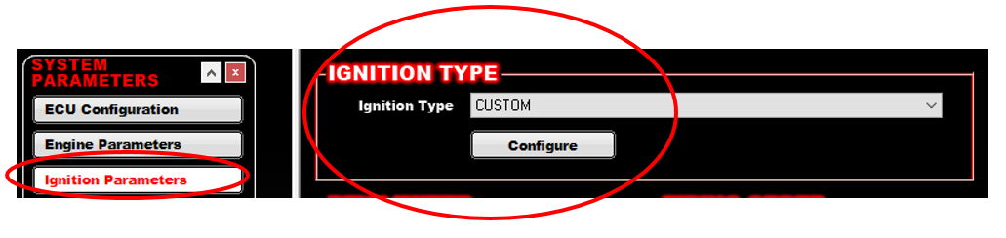
Enter an Ignition Type of “CUSTOM” then Click the “Configure” button.
The following are the proper settings for this distributor:

CRANK SENSOR, Type – 1 pulse/fire, Sensor Type – DIGITAL FALLING
Ignition Reference Angle - 50.0 degrees
Inductive Delay – This parameter is used such that ignition timing does not under or over-advance as engine speed is increased. A starting value of 100 usec can be used. But once the engine is running, the engine should (safely) be run up to 3000-4000 RPM, and timing be checked such that it matches the commanded value. If it is lower than commanded, the Inductive Delay should be increased, if higher, the delay decreased.

CAM SENSOR, Type – Single Pulse, Sensor Type – Digital Falling

OUTPUT SETUP
The following should be used if triggering a MSD Capacitive Discharge type ignition box.
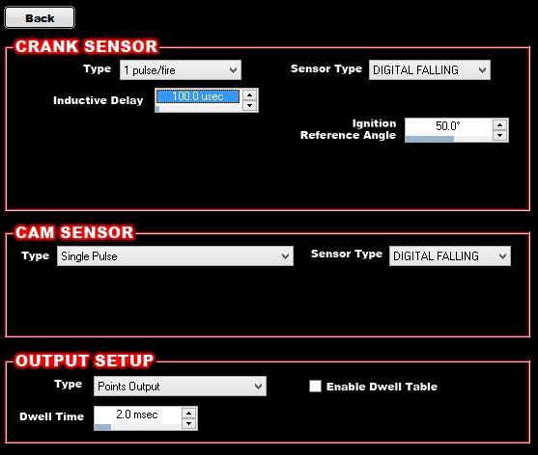
Type – Points Output

Dwell Time – 2.0 msec

If using a Coil-On-Plug or other type of output, you will need to configure the output setup properly for your specific output type.

Once the software is properly configured sync the new settings on your ECU and then proceed to Distributor removal.

DISTRIBUTOR REMOVAL:

- Disconnect the Battery NEGATIVE (-) cable and unplug the injector harness.

- Disconnect the power and or ground connection at the coil/coils. Tape up any non-insulated power and ground terminals to eliminate any chance of a short circuit.

- Rotate the crankshaft in the direction of engine rotation until it reads 50 degrees before top dead center (BTDC) on the compression stroke. Take the distributor cap off and make sure that the rotor is pointing to cylinder #1. If not, rotate the crankshaft one full revolution (as the engine is not on the compression stroke).

If your balancer is not marked at 50 degrees, take a tape measure and measure from the 0 degree mark to the following point (mark does NOT have to be exact):

Balancer Diameter | Distance
6” | 2-5/8”
7” | 3-1/16”
8” | 3-1/2”

- Remove spark plug wires and all other wiring/vacuum hoses from distributor.

- Remove distributor hold-down. Lift the distributor upwards and remove.

DISTRIBUTOR INSTALL:

NOTE1: If the engine block or heads have been milled, make sure that the distributor will fully seat and not bind or bottom out on the oil pump drive. A quick check is to remove the distributor gasket, and make sure that the distributor still fully seats on the mounting surface. If it does not, further investigation is needed. PN 565-104 utilizes an adjustable slip collar. Ensure that it is properly adjusted to allow for proper housing and gear engagement.

NOTE2 for B and RB Mopars: The distributor base will often hit the head. The base of the distributor can be ground for clearance but the position of the distributor must be determined FIRST! Decide on the plug wiring and intermediate shaft position and which terminal you want to be #1; then using the LEDs position the distributor so that you can tell where you will have to grind the base.

- Test fit the distributor.

- Coat the distributor gear with a moly paste or camshaft break-in lube.

- Position the rotor contact so it is pointing to the desired direction of the #1 spark plug wire. Insert the distributor and insure that it is fully seated (see NOTE above). The rotor will rotate as you insert the distributor. If it is does not land in the location you desire, remove the distributor and back it up a tooth or two at a time until you are satisfied with its location. You will need to make sure the oil pump drive shaft is turned in a direction that allows for the distributor shaft to mesh with it. You may have to turn the shaft with a long screwdriver or Allen wrench to position it.

- Next, connect the 10 pin distributor connector to the 10 pin Holley EFI main harness ignition adapter connector.

- Reconnect the battery cable(s), leaving the coil and injector connectors disconnected at this time.

- Turn the ignition key to the run position. (DO NOT CRANK the engine.) This will power the distributor.

- Distributor Alignment: There are two LED’s on the distributor circuit board. These will be used to align the distributor, by indicating when the crank and cam sensors are being triggered. The crank and cam LED’s are noted in Figure 1 below.
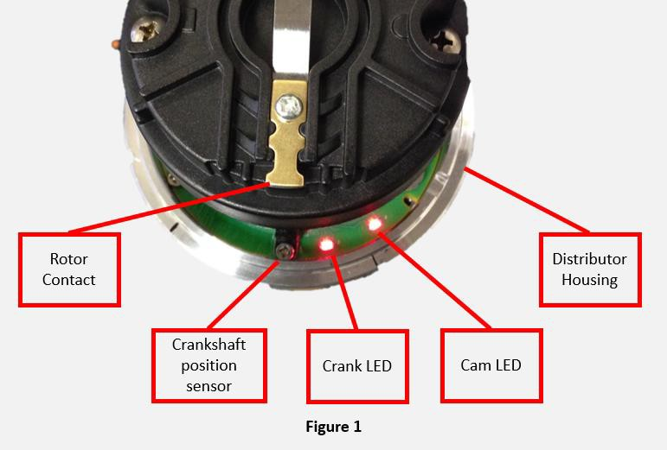

NOTE: All adjustments will be made by rotating the distributor housing only. DO NOT ROTATE THE CRANKSHAFT as it should remain at 50 degrees BTDC.

LED (ON) represents digital falling. LED (OFF) represents digital rising

Your distributor will rotate clockwise or counter-clockwise. You will need to determine the proper direction of rotation before proceeding.

Clockwise Rotor Rotation: (See chart on page 7 to determine what direction your distributor rotates.)

For engines that have the rotor rotating clockwise, turn the housing until the rotor contact is pointed at the black crank position sensor (Figure 2). Both the cam and crank LED should be illuminated (ON).
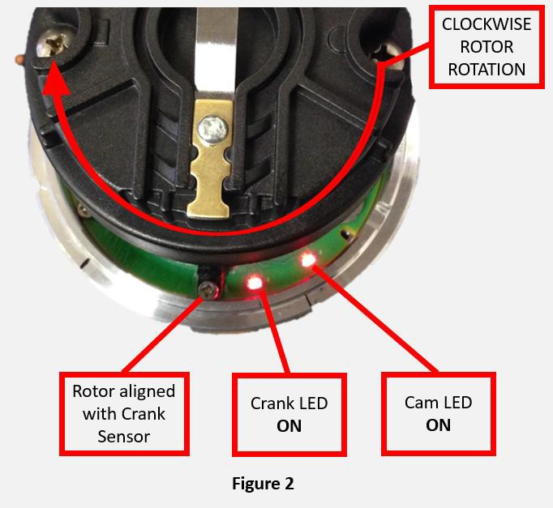

Slowly turn the housing clockwise until the Crank LED goes OFF (Figure 3).
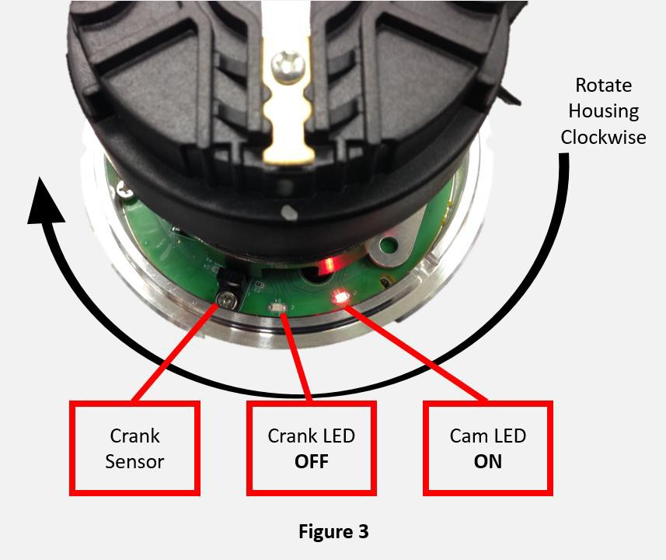

Then slowly turn the housing counter-clockwise until the Crank LED comes back ON (Figure 4). Stop at this point. This will position the distributor close to where it needs to be. Install and snug the distributor clamp down at this point.
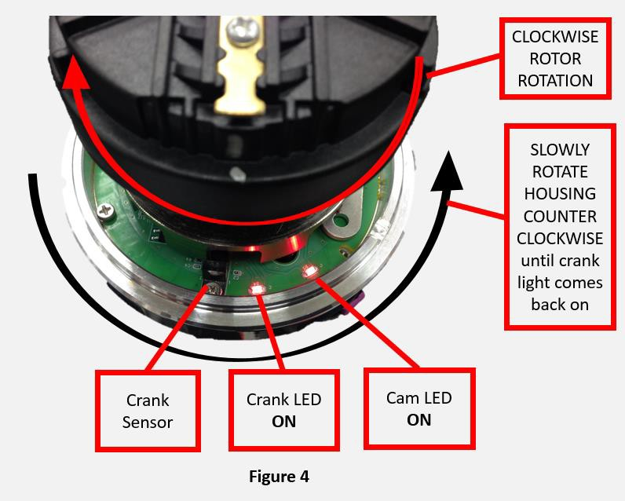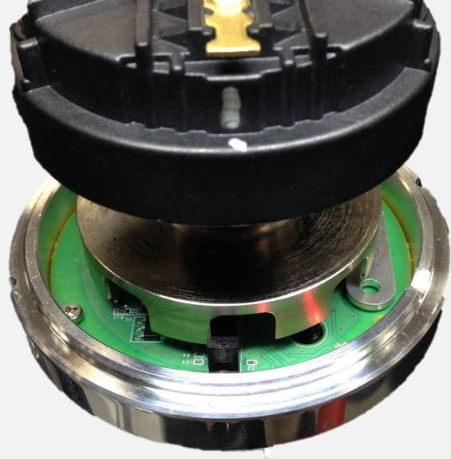

Counter-Clockwise Rotor Rotation: (See chart on page 7 to determine what direction your distributor rotates.)

For engines that have the rotor rotating counter-clockwise, turn the housing until the rotor is pointed at the black crank position sensor (Figure 5). Both the cam and crank LED should be illuminated ON.
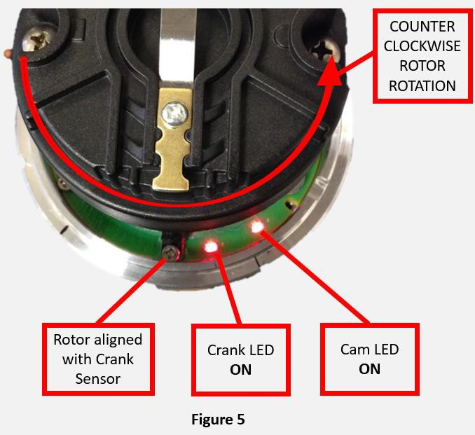

Slowly turn the housing counter-clockwise until the Crank LED goes OFF (Figure 6).
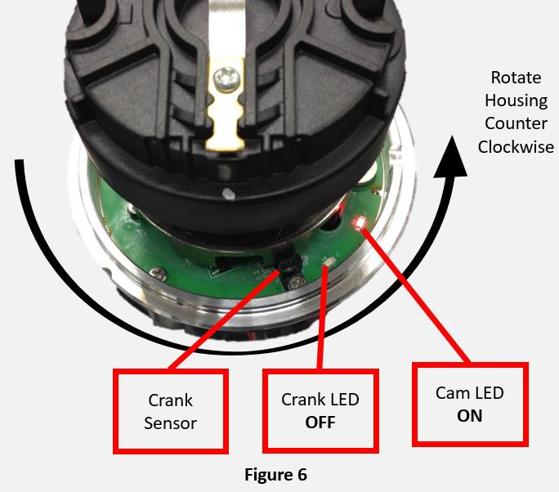

Turn the housing clockwise until the Crank LED comes back ON (Figure 7). Stop at this point. This will position the distributor close to where it needs to be. Install and snug the distributor clamp down at this point.
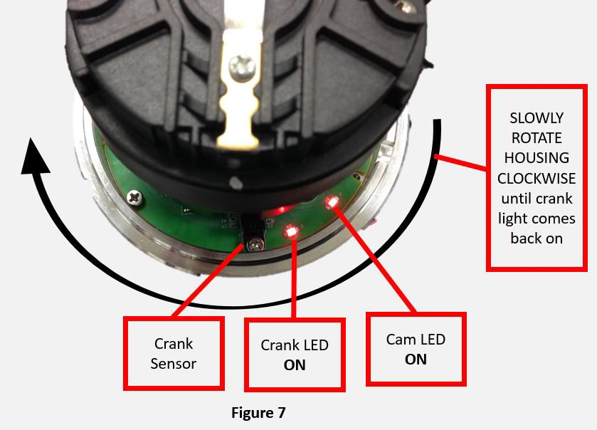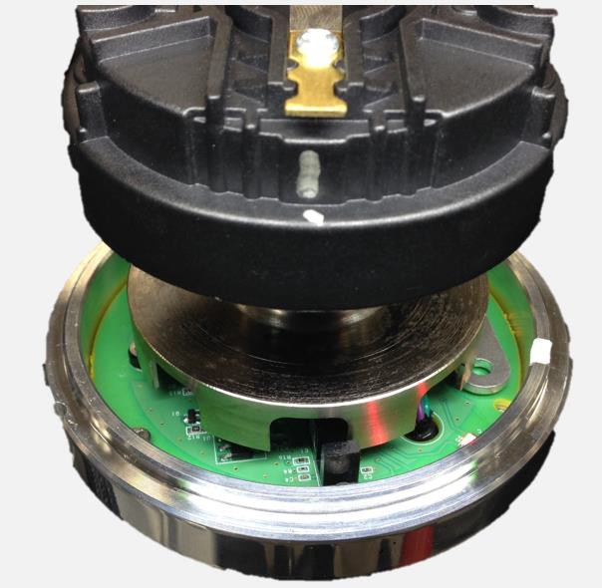

Engine Family | Rotor Rotation
Small/Big Block Chevy | Clockwise
Chrysler Small Block | Clockwise
Ford 351W | Counter-Clockwise
Ford 302 | Counter-Clockwise
BB Chrysler Wedge | Counter-Clockwise
Ford FE | Counter-Clockwise
Oldsmobile | Counter-Clockwise
Pontiac | Counter-Clockwise

- Once step 7 is completed, the rotor will be pointing to the cylinder #1 terminal on the distributor cap (ensure the engine is still at 50 degrees BTDC on the compression stroke on cylinder #1). Note which position this is on the distributor cap. Install the cap and install the #1 plug wire. Install the rest of the plug wires based on the engine’s firing order and rotor rotation. Reconnect the coil power and ground connection.

- It’s time to check the timing. Confirm that the injector harness is still disconnected from step 1. This will ensure that no fuel will be sprayed from the injectors. Crank the engine over and check the timing with a timing light.

- To make sure the ECU is getting an RPM signal, look at the “RPM” in the data monitor. Crank the engine over and make sure it shows RPM.

- Next, check the timing with a timing light, it should be whatever the cranking timing is programmed to in the software (usually 15 degrees). If it’s not close, turn the distributor until it is. Once it is, reconnect the fuel injectors and start the engine.

- Once running, check the timing with a timing light and make sure it matches the commanded timing of the ECU. It is helpful to use the “Enable Static Timing Set” feature in the software that can lock the timing to a single value. It can be found in the same drop-down as the TPS Auto-set feature. If it does not, rotate the distributor until it does.

Once synced, CAREFULLY rev the engine up to 3000-4000 RPM and make sure the timing still matches. If it is advanced, lower the Inductive Delay value by about 20. If it is retarded, raise the Inductive Delay value about 20. Cycle the ignition power after making this change. Once the timing matches at idle and higher RPM, lock the distributor down and you are done.

DISTRIBUTOR PINOUT:

If custom wiring the distributor, use the following pinout:

Connector Location | Channel | Wire Color
A | Crank Signal | Purple/White
B | Cam Signal | Purple
C | Signal Ground | Green
E | Switched +12V | Red

MISCELLANEOUS COMPONENTS:
Bronze Gear for SBC/BBC – MSD PN 8471 Replacement Cap and Rotor – Holley PN 566-100
Coil On/Near Plug Cap – Holley PN 566-101 – This low profile cover eliminates the rotor and distributor cap when using Coil-On/Near Plug ignition systems.

199R10977 Date: 8-19-16

