**6-Pack EFI Manifold Mopar RB &B**

**intake installation instructions**

Set the manifold on a table and look it over. Make sure there are no broken or bent components. If you see anything that seems strange, please call us. Please inspect the manifold for shipping debris and manufacturing debris. Blow the manifold out with compressed air before installation. If you need to disassemble the system, please note the linkage assembly and its configuration.

**Additional porting:**

If you are going to perform additional modifications to the manifold, please follow the disassembly instructions below:

* Remove fuel rails

* Remove outer throttle bodies as a pair

* Remove the central throttle body

* Remove the top plate

Cleaning: Soap and water on the top plate (no throttle bodies attached) or WD40 makes a good cleaner and brightener when rubbed by hand.

Do not use an acidic agent to clean the manifold, or the anodized finish on the top plate will be damaged. Do not use a sealant on the throttle body gaskets. You must use a sealant on the throttle body hold-down bolts. We recommend Loctite 567. They are sealed from the factory when ordered as an assembled intake system. The top plate bolts should also be sealed for re-assembly. Torque top plate and throttle body hold down bolts to 25ftlbs,

**Manifold installation:**

Before installing the manifold, decide on the routing for your fuel lines and the placement of your fuel pressure regulator. There are many ways to set up the fuel lines, so some thought into this area upfront will pay off during the installation. If you hang the regulator from the fuel rail, use a regulator mounting bracket on a motor component other than the fuel rail for support.

Remove the fuel rails from the intake by loosening the four 10-24 Allen head screws and pulling them straight up.

**Throttle cable installation:**

With the fuel rail on the left-hand side removed, install your stock cable end in the fork of the central spring loaded slider after removing the button head screw. It is set up for the stock Mopar throttle cable blade style end. If you need a different cable end effector, the "slider" should be tapped to 10-32. Pull your cable back until the slack is minimized, and tighten the cable housing into the bracket

. 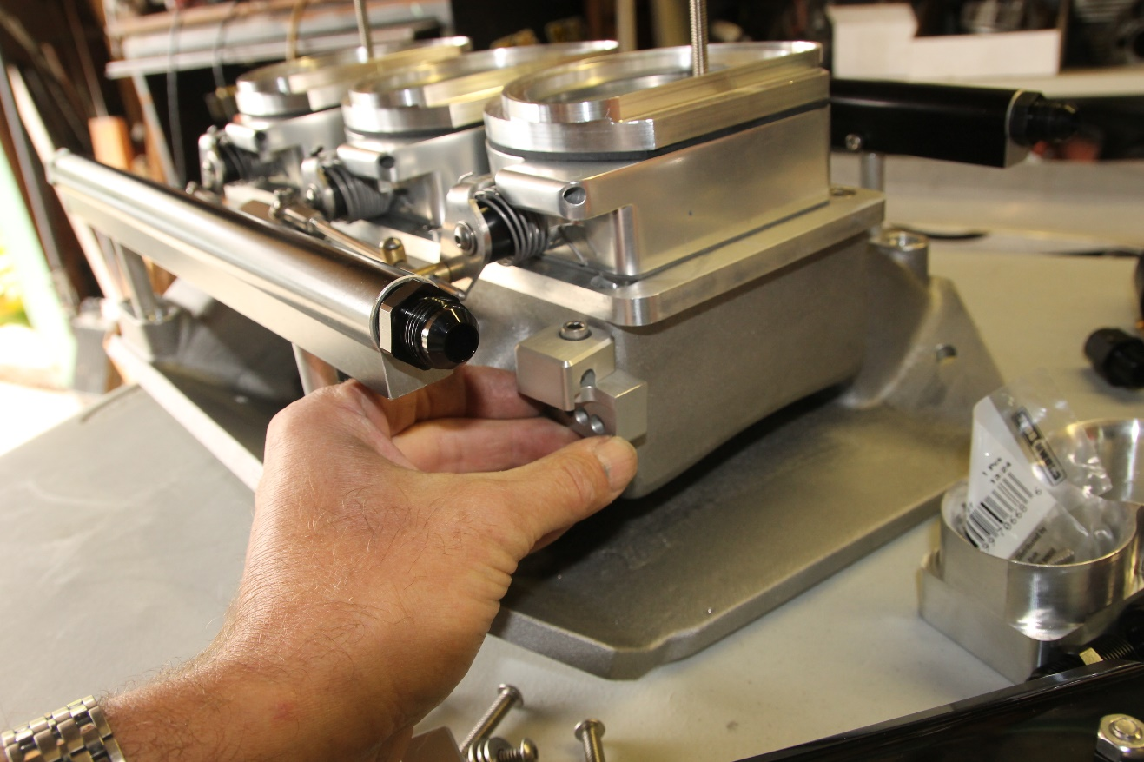

The stock Mopar kick-down rod system for automatic transmissions **will not work with the EFI six-pack.**  A cable system must be purchased from Lokar or another manufacturer. The cable kit has a bracket that can be mounted to the rear throttle body or top plate.

**Injector Installation:**

Use a good rubber lubricant (Dow 33, Mobile One engine oil, etc.) on your new fuel injector o-rings to install them in the fuel rail, avoiding shearing the o-ring. If an O-ring is sheared, it will leak and must be replaced. Angle the fuel rails and injectors down onto the manifold. Carefully press the fuel rail and injectors into the manifold bungs. Press the fuel rails on top of the rail mount "pins". Install the 10-24 screws in the fuel rails loosely. Make sure the rails are fully seated and the screws are going into the grooves on the mounting pins as you tighten them. Ensure the fuel cross-over connectors are tight using two wrenches, one on the hose fitting and the other on the rail fitting. **Do not torque on the rails without a wrench on the fitting!**

**IAC:**

The Chevrolet IAC motor, AC Delco p/n 217-435, installed in the front throttle body, will work with most fuel injection systems (FAST, Edelbrock) once the ECM wiring is determined. Check the pinout of the IAC connector of your particular fuel injection harness and connect it accordingly. The Holley EFI system requires a Mopar-style IAC motor, and it will be included in your intake kit if you tell us you are using the Holley system.

View the bottom of our Holley Tech page for specific details.

**TPS:**

The TPS is a 2-1937 Standard part. The polarity **will** be reversed from your fuel injection system's wiring. If your TPS reads full voltage with the throttle closed, reverse the two outer wires in the TPS connector or reverse polarity in the EFI software. An adaptor harness will be included to allow the use of the Holley and later FAST EZ systems.

NOTE: **Most EFI systems will allow you to change the polarity of the TPS in the software (FAST, Holley), so check there before switching wires!**

**MAP sensor:**

Connect the map sensor to the port supplied at the rear of the manifold, nearest the last runner. Your vacuum-compensated fuel pressure regulator should be connected to the other provided 3/16" port. Mount the MAP sensor as close to the vacuum port as possible to provide the best signal to the EFI computer. 6 inches should be the maximum length.

**Air Cleaner:**

The system may come with an air cleaner assembly with a filter that mounts directly onto the throttle bodies without adaptors or adaptors to allow the use of the stock air cleaner system. Both assemblies require the use of the black rubber gaskets that come with the kit and fit on the perimeter of the throttle body. Ensure the air cleaner is in the correct under-hood position and is low enough to fit under the hood before closing the hood!. We have developed a set of adaptors for the Modman to allow the use of factory cold air inlet systems (air grabber, shaker, etc.) If you ordered a cold air hood system, you should have provided these with your kit. The foam gaskets provided have an adhesive backing that allows them to be glued to the adaptors for a trouble-free service life. Contact us if your shaker is not sitting in the correct spot! The tallest adaptor is mounted to the throttle body closest to the firewall. Additional gaskets can be purchased from F&B if needed.

**Initial starting:**

**Before turning over the starter for the first time after installation, YOU MUST run the fuel pump and check for leaks at all injectors, fuel fittings, and lines. DO IT a few times!!! Ensure your fuel system has reached full pressure and DOES NOT LEAK before starting.**

The "secondary actuation slider stop should be adjusted for best performance based on vehicle build and driving style. Start with the "factory" setting for initial start-up and tuning. Once you are tuning on the road, the slider should be adjusted so that it does not actuate the outer barrels at a steady cruise speed (70mph). Your ignition map and fuel map can be adjusted at that cruise condition for maximum efficiency by adding spark advance and pulling fuel until a surge is noted, then backing off just enough to provide a steady, no-surge cruise.

If your IAC counts are too high (or low), adjust the outer throttle body blades with a 3/32 Allen wrench so that they are no closer than ½ turn from hitting the bores of the body. Recalibrate your TPS setting after adjusting the center throttle body stop. After adjusting the outer body stops, you do not have to recalibrate the TPS. Never let the blades contact the throttle body walls!

A small amount of high-temperature grease may be applied to the slider components to ensure free motion of the throttle every 3K miles or so.

Your Fuel injection system's manufacturer should cover the rest of the installation procedures. Please read their instructions all the way through! Tuning is virtually identical to a standard 4bbl throttle body setup. However, when appropriately tuned, the six-pack will allow more flexibility and better economy! Please feel free to call with any questions about your system's installation and/or tuning.