EFI and AF Ratio Control for a Bracket Car
www.fastmanefi.com

The typical EFI manifold has a crossover connection that ties the fuel rails together. This works just fine for normal applications. But when you are looking to maximize the power level the fuel flow obviously increases. This is when you might use a Y adapter from the fuel pump feed. The Y outputs feed both rails simultaneously and the regulator goes on the other end between the rails. This keeps injectors from starving their neighbors. Many EFI regulators have dual inlets. Of course the injectors must be correctly sized for the expected HP level too.
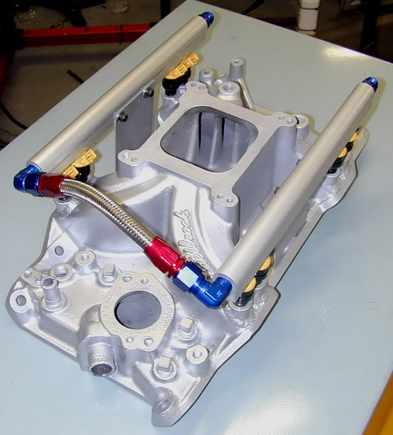
Normal Street Manifold

Race engines normally use sequential injection. Max power level for bank-to-bank is the same, so why do the extra work to get sequential? With sequential, the injector fires just as the intake valve is opening, and only one injector hits at a time as opposed to several hitting simultaneously. This allows the ECU to see the engine as 8 single-cylinder engines rather than a V8. This can tame the idle of a radically cammed motor. You can also adjust the spark and fuel on a PER CYLINDER basis. Lean cylinders at the ends of the manifold can be richened up, and EGTs can be equalized with individual cylinder spark timing.
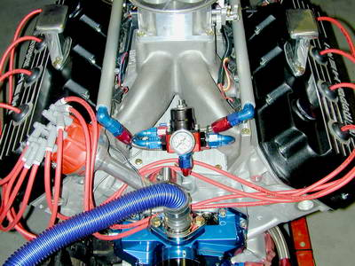
Regulator in front between rails

Sequential systems need a cam signal so the ECU knows when the injector sequence will begin. This happens once per CAM revolution.
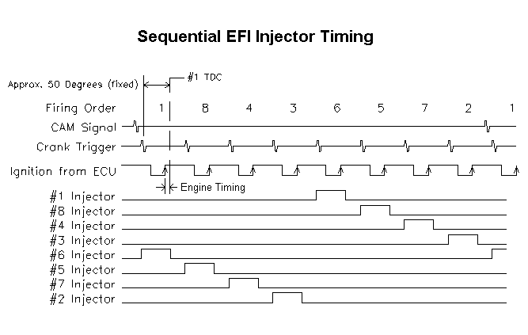

Here’s the timing we are looking for:

The cam signal happens before the crank, the crank happens at 50 degrees BTDC, the ECU computes the timing and fires the ignition box. The distributor routes it to the correct plug; meanwhile the injector on the opposite side of the firing order is injecting fuel. A dual sync distributor makes this easy, but I always use a crank trigger with a race engine since timing is more stable.

Have I forgotten anything? I handled the fuel and the spark. I guess that leaves AIR. Yes a big throttle body is required, and no, you can’t go too big with EFI. It’s easy to use too large a carburetor, but with EFI the throttle body is only an air valve. The only negative affect of an oversized throttle body is a touchy pedal. So you install a nice Dominator size throttle body with the TPS sensor. Most racing EFI engines don’t require an IAC but it doesn’t hurt if you have one.
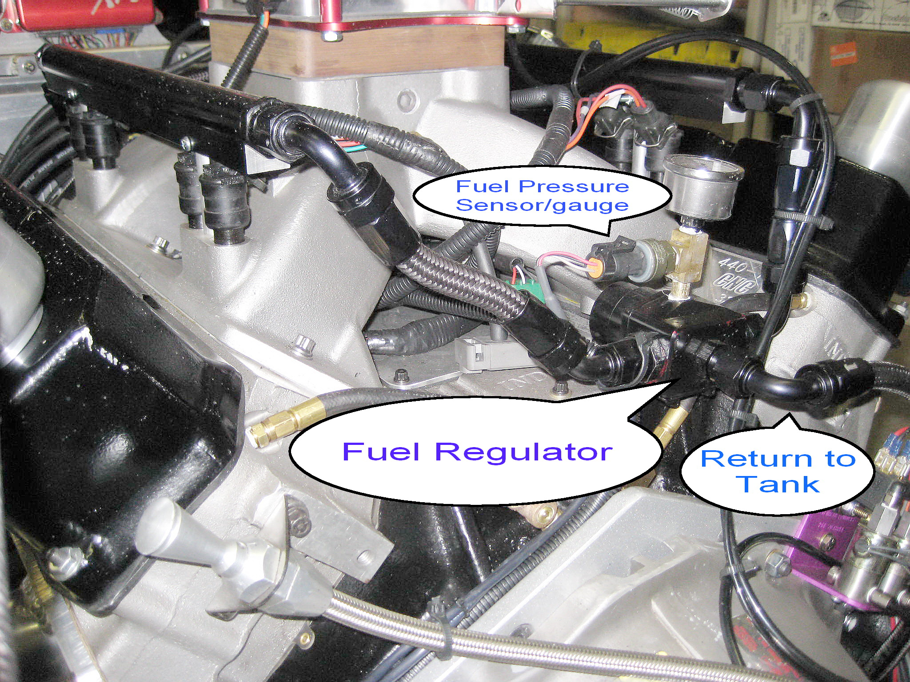

Here’s a shot showing the back of a typical application. The two fuel rails exit into the dual input regulator, where there’s a gauge and a sensor for the data logger, then a single return line back to the fuel tank.
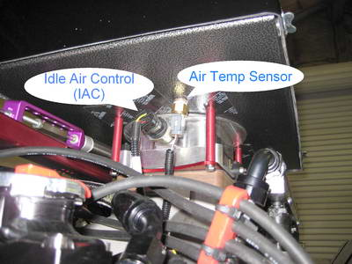
Figure 1

The underside of the air cleaner is a good spot for the air temp sensor and it also shows the IAC. Many racers don’t bother with an IAC because their idle control is iffy anyway, but I use one because I like how well the engine starts.

So let’s go to a test and tune session at the track. For most wide-open throttle racing you can tune a carburetor very well. Pro-Stock proves this. But some classes of racing use a throttle stop to help “hit the Index” or a predicted ET. In Super-Pro, Super-Street, Super-Gas and Super-Comp, the cars are launched using a delay box. A throttle stop comes on for a set period of time, then the engine goes wide open for the remainder of the race. The driver adjusts how long the engine is “on the stop” to hit the Index or Dial. It’s confusing to watch but that’s bracket racing.

We first took the car to a test-and-tune session, made a pass, and data logged some key parameters.
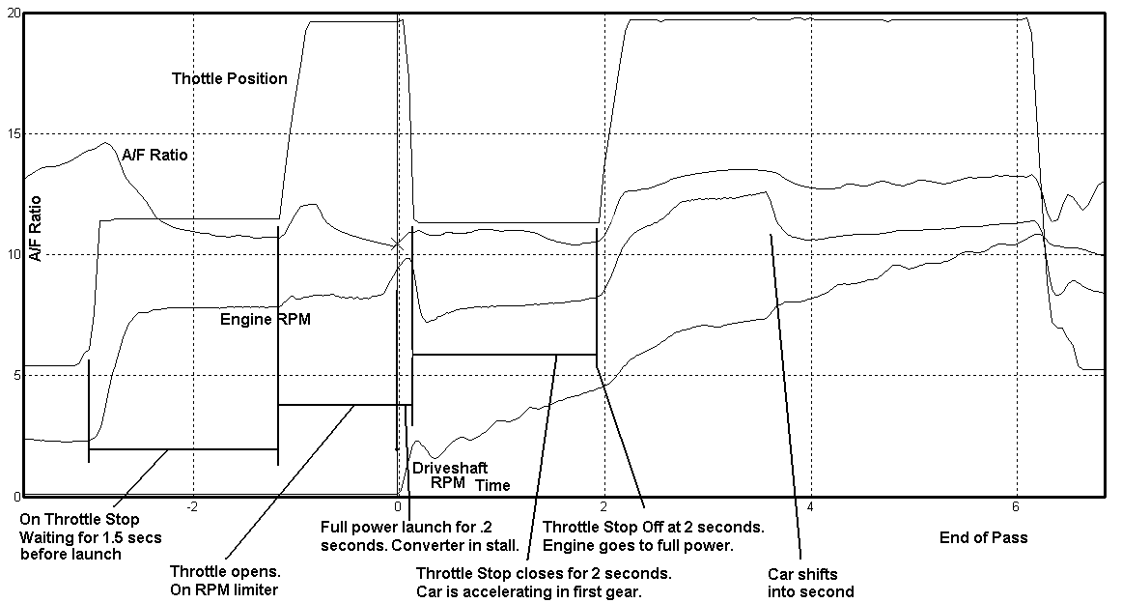
Figure 2

Take a second and study this log. I made the vertical axis A/F ratio and the horizontal axis time. Here’s the sequence of events:

* Once the car is staged (about 3 seconds before the start of the race), the driver pushes the transbrake button and hammers the throttle. The throttle stop goes to about ½ throttle so you’re not straining the engine against the converter.

* At the TOP light (1.5 seconds before the green) the driver releases the transbrake button. The throttle goes wide open, and engine RPM increases to the preprogrammed launch RPM, which is just below the converter stall.

* When the delay box releases the transbrake, the RPM limiter is removed, the engine RPM goes to converter stall, and the car launches at full power to get a consistent launch.

* The throttle stop comes back on .2 seconds later. Notice the driveshaft RPM is now increasing. The car stays “on the stop” in this example for 2 seconds while in first gear.

* 2 seconds later the car goes full throttle for the remainder of the race.

* At a set RPM, approximately 3.8 seconds later in this case, the car shifts into second. (It’s a 2 speed Powerglide).
Notice that the A/F ratio was changing quite a bit during the pass. This would be typical for a carbureted engine. A/F ratio spiked when the throttle first opened, and then settled down into the 11:1 range before the launch. This is too rich. Then during that 2 second period after the launch, when the stop was on, the A/F ratio hovered around 11.5:1. Once the throttle opened up, the A/F ratio finally settled in at around 12.8:1. Maximum power and consistency is about 12.8:1.

The biggest problem with this tune up is that the A/F was not consistent. We always start tuning engines on the rich side just to be safe, but we’re pretty far off. Using the manifold vacuum and RPM parameters we leaned out those portions when the stop is on and made other adjustments to the acceleration fuel (the pump shot). Here is the data log after three tuning passes:
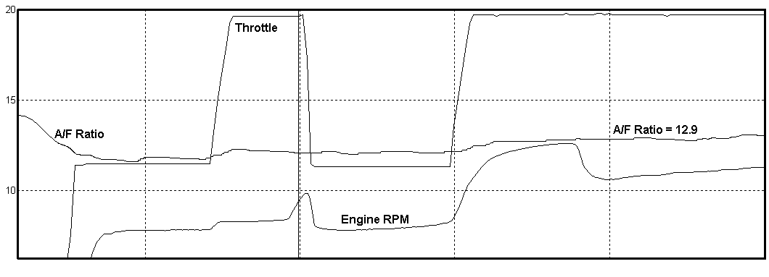
Figure 3

Notice the stability of the A/F ratio. Notice also that everything is smoother, even during throttle transitions. The car’s elapsed time dropped by almost .2 seconds, but even better was the consistency. After tuning, at the first real race, the 60 foot times for 3 consecutive passes were all within .002 seconds! That’s + or - .001 or 1/ 1000 of a second. In addition, the car consumed less fuel and was deadly consistent. The owner of this car has won several NHRA Wallys and loves the combo since it adjusts for different tracks. The biggest variable is his reaction time which EFI can’t help.

This same approach was used for a blown alcohol engine with 8 EGTs. The individual cylinder tuning allowed us to equalize the engine for a very consistent and safe result.

