EFI Expert
21575 Apple Hill Dr.
Sonora, CA 95370
209-247-6497
rich@efiexpert.com

Holley Crank Sensor Setup

Crank Sensor Setup – “one pulse per fire” trigger

A “one pulse per fire” trigger means there is one pulse for every cylinder firing (on a V8 this would be a 4 pulse crank trigger or an 8 tooth reluctor in the distributor).

In the software, the Sensor Type should be set up as “Magnetic” or Digital as appropriate.

1. Set the Ignition Reference Angle in the software to 60 degrees
2. Turn the engine over to 60 degrees BTDC on cylinder #1 compression stroke.
3. Align/turn the crank trigger or distributor so that the sensor is in line.
4. Tighten everything up.
If you are not using a cam sync, everything will be close enough to start the engine. Disconnect the injectors and crank the engine while using a timing light. It should be firing at or close to the timing value on the data monitor. If it is off a few degrees, you can move the pickup slightly, or change the Ignition Reference angle setting to sync things up. If you change the Ignition Reference value, note that you must cycle the ignition power for it to take effect.

Crank Sensor Setup - 60-2 (58X) Wheel

The “60-2” trigger wheel has 58 teeth with “2 missing”. This is also known as a “58x” wheel. More teeth allow the ECU to more precise engine speed calculation during RPM transitions compared to less teeth.

1. Rotate the engine to #1 TDC.
2. The parameter called “TDC Tooth Number” is typically set to “10”.
3. With the engine at TDC on #1 cylinder, the sensor will be positioned such that it is lined up with the “TDC Tooth Number” (for this example 10).
Most engines rotate clockwise, except for Honda engines which rotate counterclockwise. If you are confused about which tooth this means, put the trigger wheel on the engine and rotate just the trigger wheel (leave the engine at TDC on #1) in the direction the engine rotates. Rotate it until the missing teeth/gap line up to where the sensor will be mounted, then continue turning it and count 10 teeth. Take a marker and mark this tooth. It will be the tooth you need to align with the sensor.

CAM Sensor Setup

A cam sync pulse is required if you are running sequential fuel injection. This tells the ECU which cylinder is cylinder #1 (or the first cylinder in the firing order as entered in the software).

Cam Sync setup when using a “one pulse per fire” crank input

For a "one pulse per fire crank” signal (e.g. a 4 pulse crank trigger on a V8), the cam sync signal must occur in a specific range to properly identify which cylinder is cylinder #1. If this is not done properly, individual cylinder trims will not work correctly, or worse, if using individual coils, the wrong cylinder will be fired, potentially damaging parts.

The best way to determine the proper range is by using the following basic formula:
Cam sync location (degrees BTDC #1) = "Ignition Reference Angle" + “A” + (“A” / 2)
“A” = Angle Between Crank Pulses (crank degrees between triggers on the crank sensor)

“A” for a 8 cylinder = 90°
“A” for a 6 cylinder = 120°
“A” for a 4 cylinder = 180°
Using the formula above, plug in the “Ignition Reference Angle” you are using and the proper “A” value depending on the number of engine cylinders. The location calculated is the “ideal” location and can vary +/- 30 degrees or possibly more.
Example - 8 cylinder with a Ignition Reference Angle of 60°
Cam Sync Location = 60 + 90 + 90/2 = 195 degrees BTDC #1
This location can vary by +/- 30 degrees from this nominal target value with no issue.

NOTE: If it is mechanically not possible to install the cam trigger in the proper location, the engine firing order can be changed in the software to compensate for this.

Cam Sync setup when using a 60-2 crank input

Position the cam sensor such that it is between 110 -250 degrees before TDC on cylinder #1.
This cam sync input can be configured as a Magnetic or Hall-Effect (digital rising or digital falling) input in the software. Make sure that if you are using a Hall-Effect sensor, you have this set up properly as a rising or falling signal.

Special Cases

Case 1: Ford Modular Setup in Custom Ignition Parameters
Because the stock location of the cam pulse on the Ford Modular engines occurs about 25 degrees or so after #1 firing TDC, this conflicts with our normal convention (crank gap immediately after the cam pulse corresponds to first cylinder in firing order). So you have to juggle the firing order. The cam pulse is circled, and the following crank gap has the yellow arrow. Since this corresponds to cylinder 6 instead of cylinder 1, you start the firing order with 6. 6-5-4-8-1-3-7-2 being the result. Below is a graphic with some offset and filtering settings (that only have an effect with the J+ ECUs). It is important to realize you do NOT have to juggle the firing order when you are using the “canned” ignition type, only the Custom Ignition Type. Also, ensure you enter the correct Dwell Time for the ignition coils you're using.
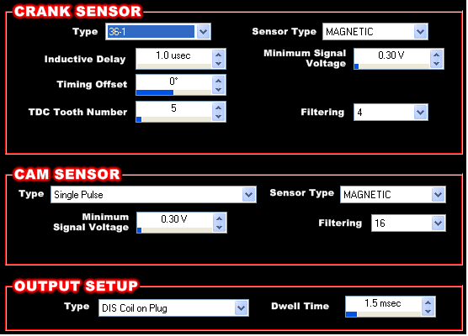
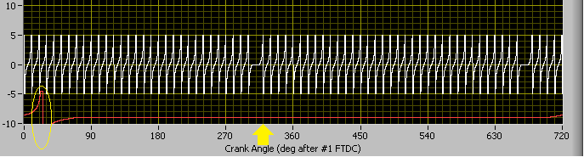

Case 2: Using a 1 Pulse/Fire Crank Trigger with a Chrysler NGC Cam Pattern
The Chrysler NGC cam signal is a pulse width encoded pattern. The ECU looks for a certain pattern and you can think of it as throwing a flag at a certain point in the pattern when it recognizes it. This normally happens at the rising edge of the cam pulse that is nominally about 15 degrees before #1 firing TDC. Ideally this would happen about 180 degrees before firing TDC so it would fall into line with our current crank/cam reckoning convention for 1 pulse per fire crank patterns (the second crank tooth after the cam pulse corresponds to the first cylinder in the firing order). Since it does not, you have to juggle the firing order. The timing of the cam decode “event” is circled and the second crank pulse thereafter is marked with the yellow arrow. Since this corresponds to cylinder 4 instead of cylinder 1, you start the firing order with 4. 4-3-6-5-7-2-1-8 being the result.
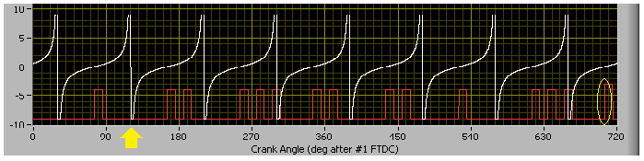

Case 3: Using a 1 Pulse/Fire Crank Trigger with a GM 4x Cam Pattern
The GM 4x cam signal is a pulse width encoded pattern. The ECU looks for a certain pattern and you can think of it as throwing a flag at a certain point in the pattern when it recognizes it. This normally happens at the falling edge of the cam pulse that is nominally about 210 degrees before #1 firing TDC. Luckily this falls into line with our current crank/cam reckoning convention for 1 pulse per fire crank patterns (the second crank tooth after the cam pulse corresponds to the first cylinder in the firing order). The timing of the cam decode “event” is circled and the second crank pulse thereafter is marked with the yellow arrow. However, you will notice that this graphic is with a crank pulse that happens at 60 degrees before TDC. It is very important that the crank pulse is not retarded past the cam edge that is circled, nor too close that would result in the edges crossing during a transient event. Because of this, you will probably not want to use an ignition reference angle less than 40 degrees or so. It is also important to record a system log after the engine is fired to make sure you have adequate margin since there is variation in the timing of cam pulses.
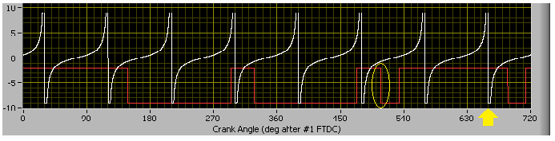

Case 4: Using a 1 Pulse/Fire Crank Trigger with a Factory GM LSx 1x Cam Pattern
To properly phase the cam trigger location in reference to cylinder #1 compression stroke, setup the configuration as follows:
Engine Firing Order = 7-2-6-5-4-3-1-8
Ignition reference Angle = Set between 40-60 degrees
Cam Sensor Type = Single Pulse
Sensor Type = Digital Falling

Magnetic Sensors:

Magnetic sensors are also called Inductive sensors. They are basically just a coil that generates a signal when the magnet passes by. The output voltage is dependent on RPM and the polarity must be correct. This is because the ECU circuitry uses what’s called a “zero crossing detector”. This is what the correct signal from a magnetic sensor should look like:

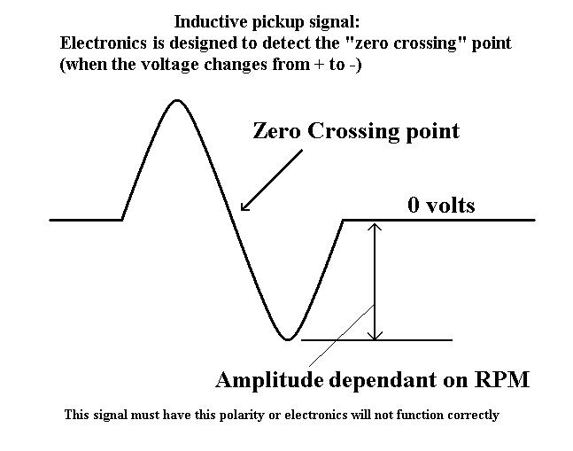
The amplitude is small (1/10 of a volt) at low RPMs so this type of sensor is susceptible to electrical noise. Care must be taken to shield these signals, use twisted pair wiring and polarity must be correct.

