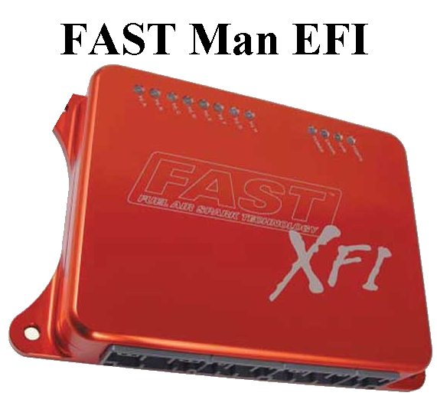
FAST Man EFI
21575 Apple Hill Dr.
Sonora, CA 95370
209-247-6497

MSD Distributor to CAM Sync Instructions:

The CAM sync must happen before the crank pulse on cylinder #1 firing stroke. Since this conversion ONLY provides the CAM sync signal the crankshaft reference signal must come from another source such as a crank trigger. Since the crankshaft reference should occur at 50 degrees BTDC this conversion should generate the cam sync pulse well before that, but after the last cylinder fires. This can be TDC of the previous cylinder. The distributor must also be locked out.

The timing of this CAM sync pulse is not critical. It can occur anywhere from 60 degrees BTDC to 115 degrees BTDC on cylinder #1.

Conversion:
The MSD distributor must be disassembled and the reluctor removed. You grind off 7 teeth such that the remaining tooth occurs at TDC of the last cylinder in the firing order.

Installation after conversion:
1) Set the engine to about 25 degrees BTDC on cylinder #1. Make sure it’s the compression stroke.
2) Install this distributor as required to point the rotor directly at the #1 terminal. Since the rotor is locked out, this allows the timing from the ECU to vary from 10 degrees to 40 degrees without the rotor ever being out of phase.
3) Lock down the distributor.
4) Manually rotate the engine to make sure that the cam signal will happen before the 50 degree crank trigger. There is no need to ever move the distributor from this point on.

In the XFI software under Operational parameters, make sure the ignition is set to IPU and that you have disabled the discrete cam input.

